PROJECT : STREAMLINING TICKET ASSIGNMENT FOR EFFICIENT SUPPORT OPERATIONS

TEAM MEMBERS
TAMILSELVI D
RAJARAJESWARI S
YUVASRI D
SAIDHANYA J
PROJECT REPORT

1.INTRODUCTION

2.IDEATHON PHASE

3.REQUIREMENT ANALYSIS

4.PROJECT DESIGN PHASE

5.PROJECT PLANNING PHASE

6.PROJECT DEVELOPMENT PHASE

7.ADVANTAGES & DISADVANTAGES

8.PROJECT DOCUMENTATION

9.CONCLUSION

- INTRODUCTION

1.1 Project Overview
Streamlining Ticket Assignment for Efficient Support Operations is a system developed to automate the process of assigning support tickets to the appropriate teams using the ServiceNow platform. In many organizations, customer support teams receive a large number of service requests or issue tickets every day. These tickets are often assigned manually to different teams such as platform support, certification support, or technical teams.
Manual ticket routing can lead to delays, incorrect assignments, and inefficient handling of customer issues. When tickets are not assigned to the correct team, the issue resolution process becomes slower and customers may experience dissatisfaction.
This project aims to automate the ticket assignment process by using ServiceNow’s workflow automation capabilities. The system identifies the type of issue reported in the ticket and automatically assigns it to the appropriate support group. By implementing this automated routing mechanism, the support department can improve operational efficiency and ensure faster resolution of issues.

1.2 Purpose
The main purpose of this project is to develop an automated ticket routing system that improves the efficiency of support operations. Instead of manually assigning tickets, the system automatically routes them to the correct support group based on the issue type.
The project also aims to reduce delays in ticket handling, improve customer satisfaction, and ensure that the support team works more efficiently. By using ServiceNow features such as users, groups, roles, tables, access control, and flow designer, the project simplifies the process of ticket management and assignment.

2.IDEATION PHASE

2.1 Brainstorming –Idea Generation –Prioritization
Brainstorming is the process of generating ideas and exploring possible solutions for a problem. In this phase, different ideas were discussed to identify an effective solution for managing employee data in organizations. Initially, several ideas were generated to improve the process of handling employee information. These ideas included developing a digital database for employee records, creating an automated system for employee data entry, implementing workflows for approval processes, and generating automated notifications for updates. After generating multiple ideas, the most suitable solution was selected based on feasibility and efficiency. The idea of Automating Employee Data using ServiceNow was prioritized because it allows organizations to store and manage employee information efficiently through automation. This solution reduces manual work, improves accuracy, and helps organizations maintain organized employee records. Thus, the brainstorming process helped identify automation as the best solution for managing employee data.

2.2 Define Problem Statement
ABC Corporation, a leading technology company, faced difficulties in managing and assigning support tickets to the appropriate teams. With multiple products and services offered by the organization, support teams received a large number of tickets daily.
The manual process of assigning tickets often resulted in incorrect routing, delays in issue resolution, and reduced customer satisfaction. Support staff had to spend significant time analyzing each ticket and determining the correct team responsible for handling the issue.
Therefore, there was a need for a system that could automatically route tickets to the appropriate support groups based on the issue type. The proposed solution is to develop an automated ticket assignment system using the ServiceNow platform that ensures accurate and efficient ticket routing.

2.3 Empathy Map Canvas
The empathy map helps to understand the needs, challenges, and expectations of users interacting with the system. In this project, the primary users are support administrators and support engineers.
Says:
Users say that manually assigning support tickets is time-consuming and increases the chances of mistakes.
Thinks:
Users believe that an automated system would make ticket management easier and improve the efficiency of the support team.
Does:
Currently, users manually review each ticket and assign it to a support group depending on the issue category.
Feels:
Users often feel stressed and frustrated when there are many tickets to assign because manual routing requires time and careful analysis.
Understanding these user concerns helped design a system that automatically assigns tickets to the correct team and simplifies support operations.

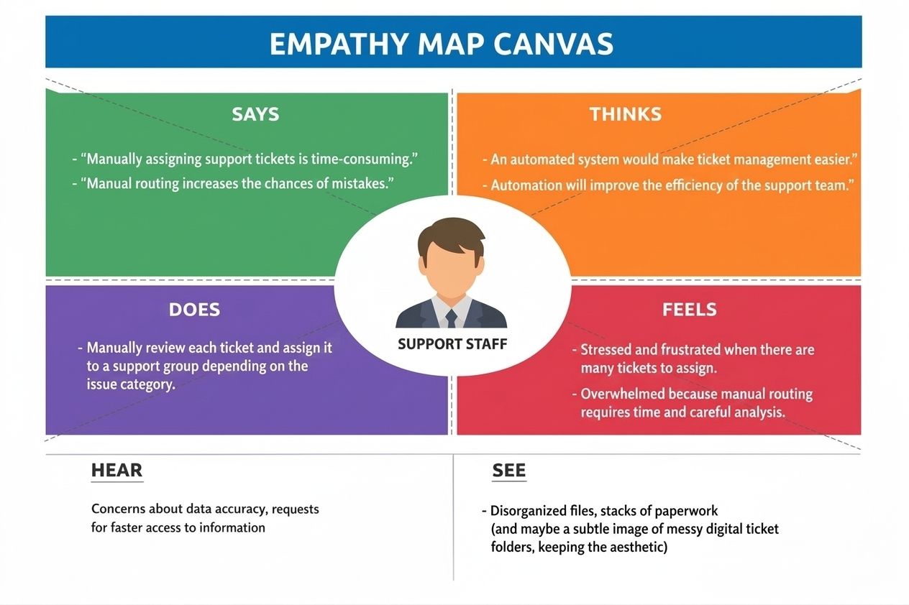
3. REQUIREMENT ANALYSIS

3.1 Data Flow Diagram and User Stories

A Data Flow Diagram (DFD) describes how data flows within the system.
In this project, the process begins when a user creates a support ticket by entering issue details in the ServiceNow form. The system processes the ticket information and identifies the issue category. Based on the category, the system automatically assigns the ticket to the appropriate support group.
The ticket information is stored in a ServiceNow database table where administrators and support engineers can view and manage the records.
The major components of the system include:
Input:
User enters ticket details such as issue type and description.
Process:
The system analyzes the issue type using automation flows.
Storage:
Ticket information is stored in the ServiceNow table.
Output:
The ticket is automatically assigned to the appropriate support group.

User Stories
• As a support user, I want to create a ticket so that my issue can be resolved.
• As a support administrator, I want tickets to be automatically assigned to teams so that manual routing is reduced.
• As a support engineer, I want to view tickets assigned to my group so that I can resolve issues quickly.
• As a system administrator, I want the system to notify teams when new tickets are assigned.

3.2 Solution Requirements
Functional Requirements
• The system should allow users to create support tickets.
• The system should store ticket details in a ServiceNow table.
• The system should automatically assign tickets to support groups based on issue type.
• The system should allow administrators to manage users, groups, and roles.
• The system should provide access control for security.
Non-Functional Requirements
• The system should be easy to use.
• The system should provide secure access to data.
• The system should process ticket assignments quickly.
• The system should operate reliably without system failures.

3.3 Technology Stack
The project is developed using the ServiceNow platform, which provides tools for workflow automation and service management.
ServiceNow Developer Instance:
Used as the development environment for creating the application.
ServiceNow Tables:
Used to store ticket information such as issue type, description, and assigned group.
Users, Roles, and Groups:
Used to manage system access and assign responsibilities to different teams.
Access Control (ACL):
Used to control permissions and ensure that only authorized users can access certain data.
Flow Designer:
Used to automate the process of assigning tickets to appropriate support groups.
These technologies work together to create a reliable and automated support ticket management system.
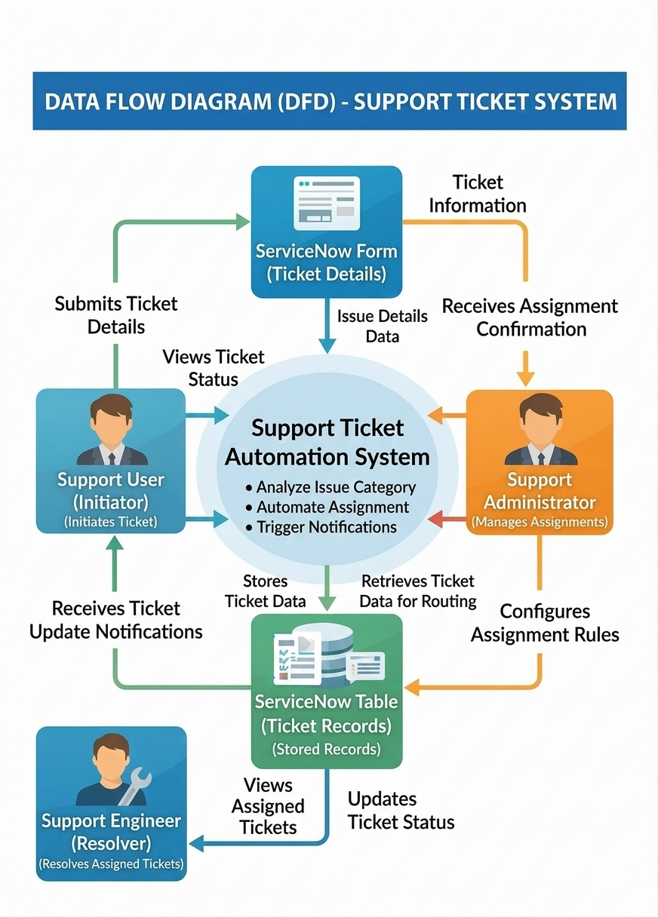

4. PROJECT DESIGN PHASE

4.1 Problem – Solution Fit
The main problem faced by organizations is the inefficient manual routing of support tickets. When support tickets are assigned manually, there is a high chance of errors and delays.
The proposed system solves this problem by implementing automated ticket routing using ServiceNow. The system identifies the issue category and automatically assigns the ticket to the appropriate group such as the platform team or certification team.
This solution improves the efficiency of support operations and ensures that issues are resolved faster.

4.2 Proposed Solution
The proposed solution is to develop an automated ticket assignment system that uses ServiceNow Flow Designer to route tickets to the correct support groups.
When a ticket is created, the system checks the issue type. If the issue is related to certificates, the ticket is assigned to the Certification Support Group. If the issue is related to the platform, the ticket is assigned to the Platform Support Group.
This automated process reduces manual intervention and improves ticket resolution time.

4.3 Solution Architecture
The system architecture consists of several components that work together.
- User Interface – Users create support tickets through ServiceNow forms.
- Database Table – Ticket information is stored in the operations-related table.
- Access Control Layer – ACL rules ensure secure access to data.
- Automation Layer – Flow Designer analyzes ticket details and assigns them to appropriate groups.
- Support Groups – Platform and Certification teams receive tickets assigned to them.
This architecture ensures smooth data flow and efficient ticket assignment.
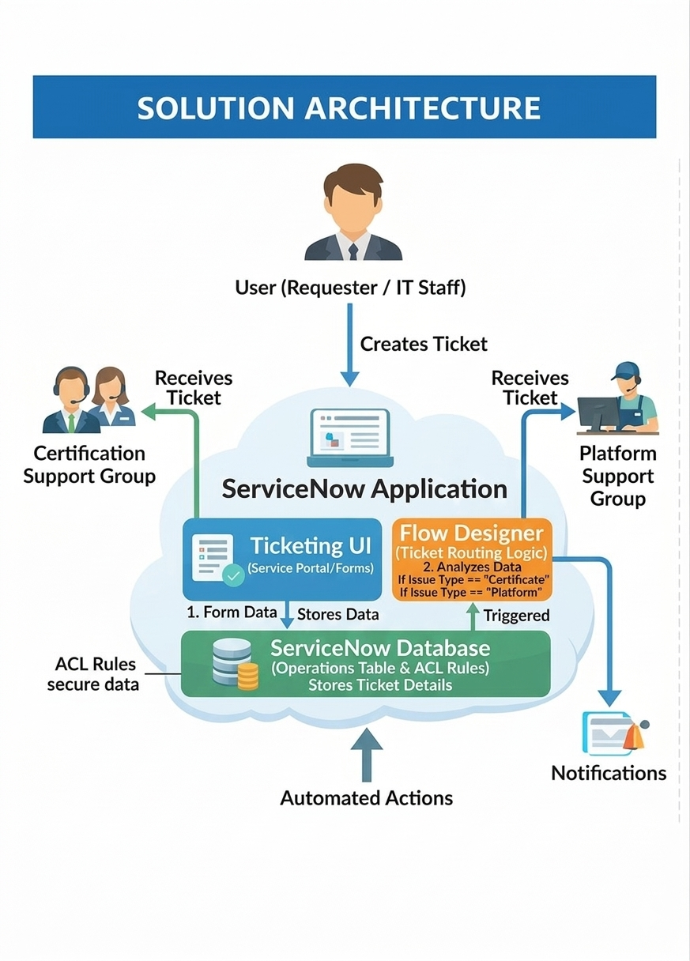

5. PROJECT PLANNING PHASE

5.1 Project Planning
Project planning involves organizing activities required to complete the system development successfully.
The planning phase started with identifying the problem of manual ticket assignment. After understanding the issue, the project objectives were defined to develop an automated ticket routing system.
The next step was selecting the ServiceNow platform for implementation. After selecting the platform, the system design was planned, including the creation of users, groups, roles, tables, and workflows.
The project was developed step-by-step by creating system components and integrating them using automation flows. Testing was also planned to verify the functionality of the system.
Proper planning ensured that the project was completed in an organized and efficient manner.
6. PROJECT DEVELOPMENT PHASE

6.1 System Implementation
During the development phase, the system components were created within the ServiceNow platform.
Users were created to represent individuals interacting with the system. Groups were created to represent support teams such as the Platform team and Certification team.
Roles were assigned to users to define their responsibilities and access levels. A database table called Operations Related was created to store ticket information.
Access Control Lists (ACLs) were implemented to ensure that only authorized users could access specific records.
Automation flows were developed using Flow Designer to automatically assign tickets to support groups based on the issue category.
The development phase successfully integrated all components to create a fully functional ticket assignment system.
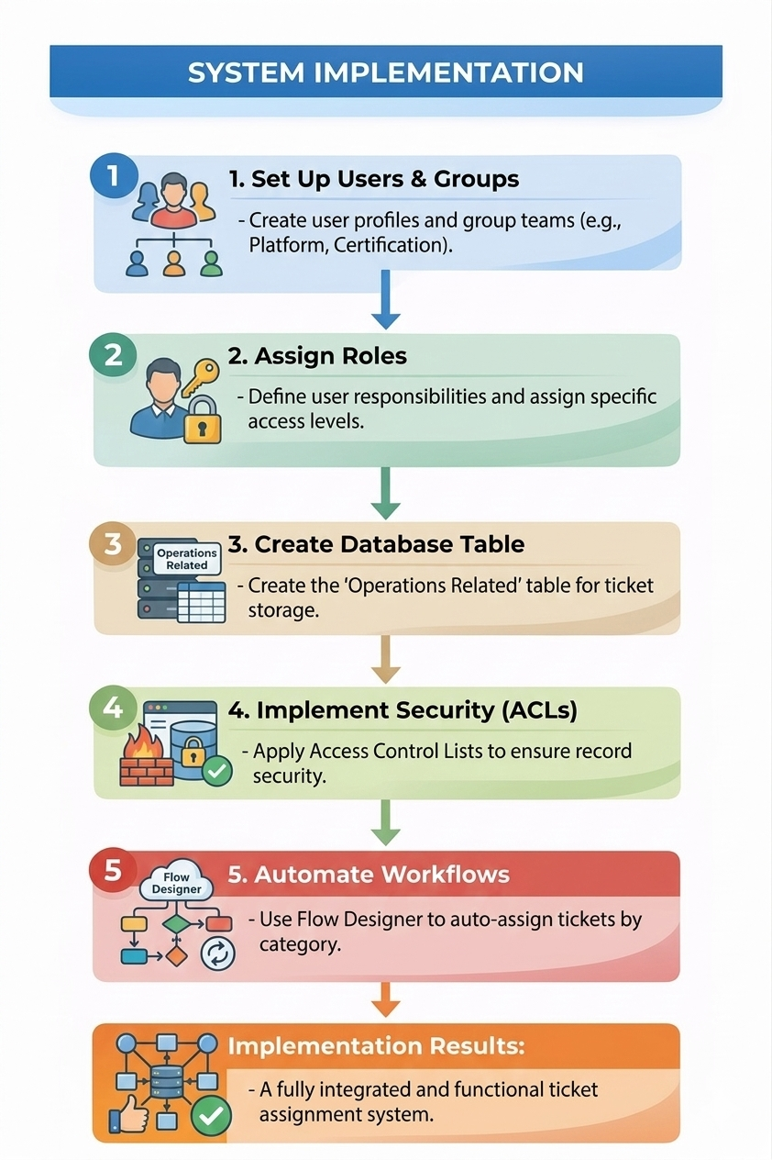

7. ADVANTAGES & DISADVANTAGES

Advantages
• Reduces manual effort in assigning support tickets
• Improves efficiency of support operations
• Ensures tickets are assigned to the correct team
• Reduces delays in issue resolution
• Enhances customer satisfaction

Disadvantages
• Requires internet connectivity to access ServiceNow
• Initial setup requires technical knowledge
• System depends on the ServiceNow platform availability

8. PROJECT DOCUMENTATION

8.1 Final Report

The final report presents a comprehensive overview of the project titled Streamlining Ticket Assignment for Efficient Support Operations.
The project was developed to solve the problem of inefficient manual ticket assignment in support departments. By implementing automation using the ServiceNow platform, the system automatically routes tickets to the correct support groups.
The project includes several development stages such as ideation, requirement analysis, system design, project planning, development, and testing. Each phase contributed to building an effective ticket management system.
The final system successfully demonstrates how automation can improve the efficiency of support operations and ensure faster issue resolution.

8.2 Screen Layout

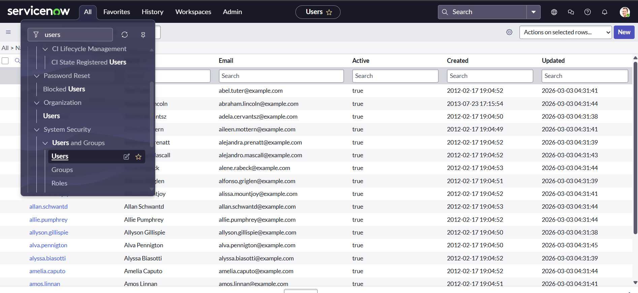

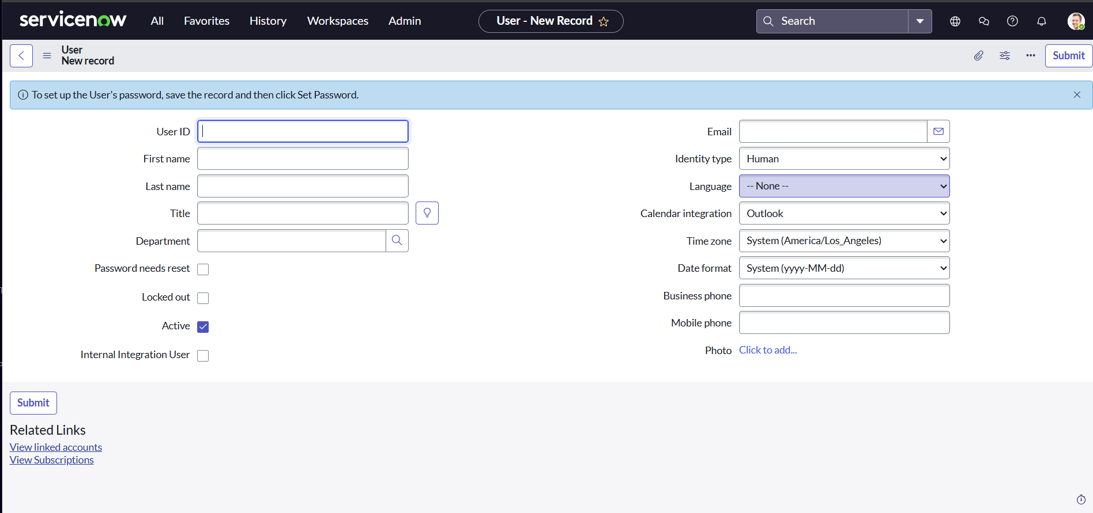

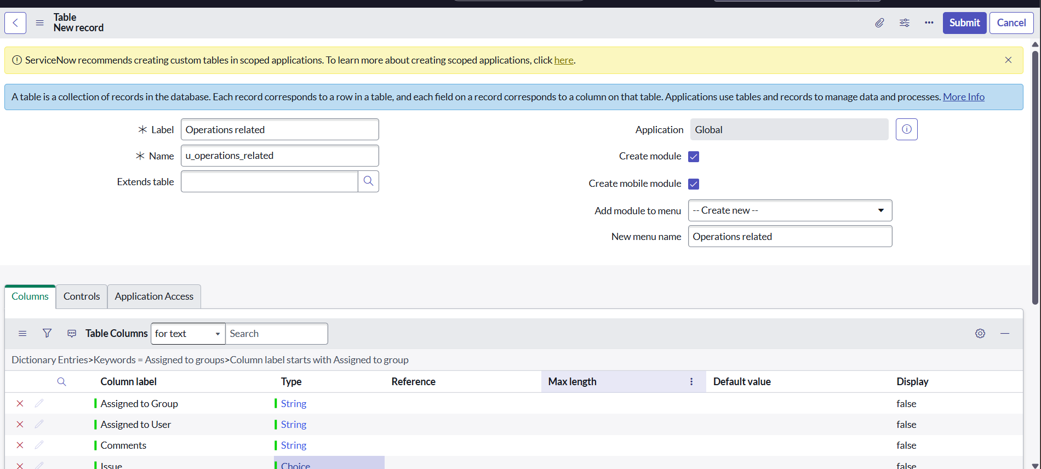

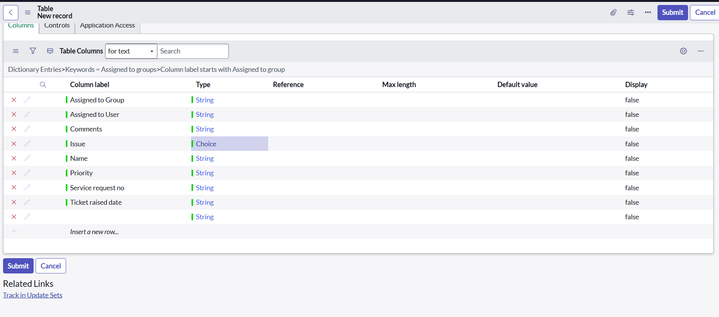

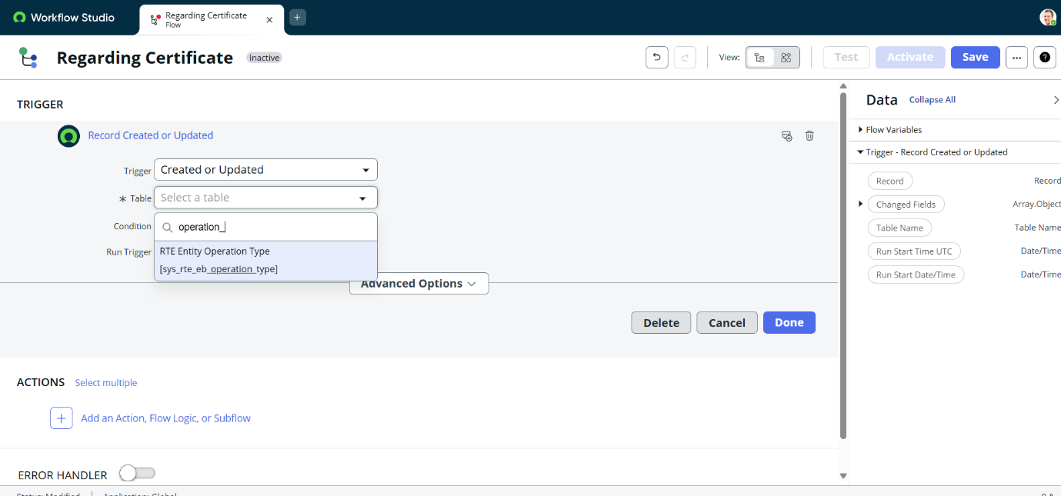
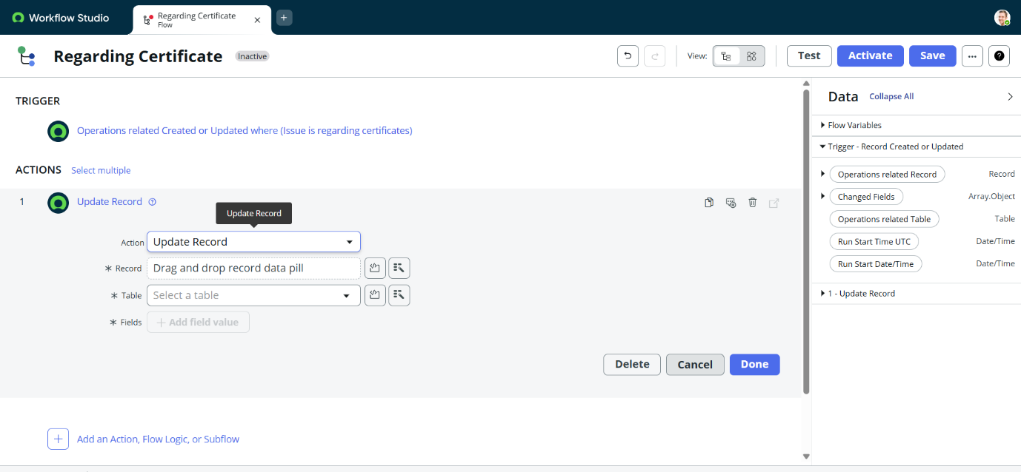
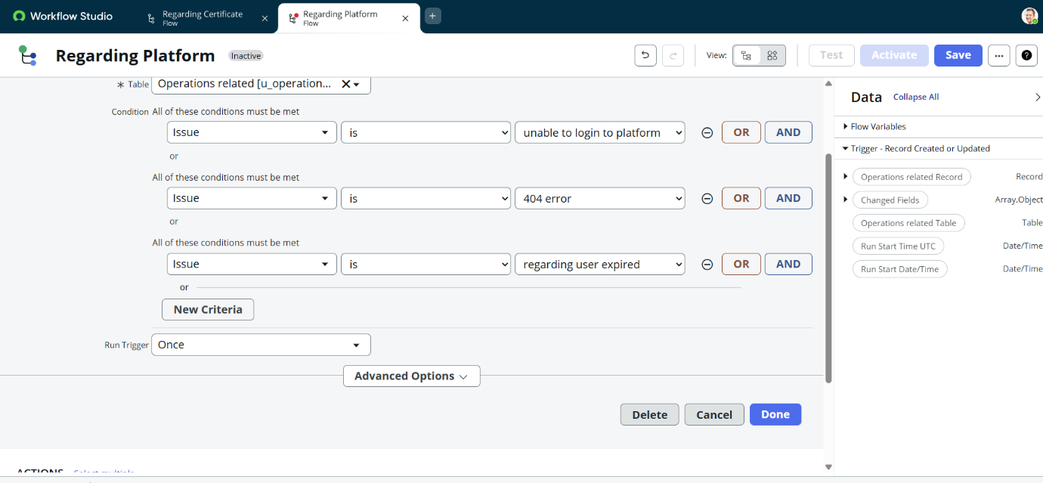
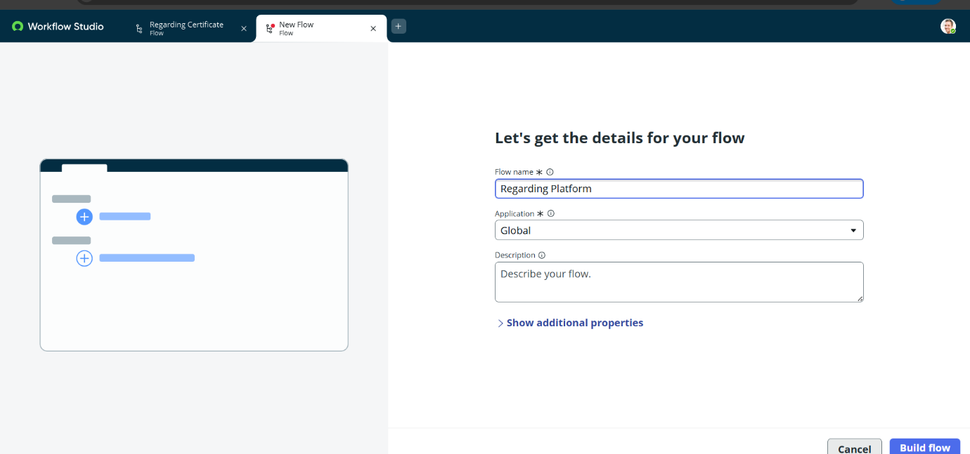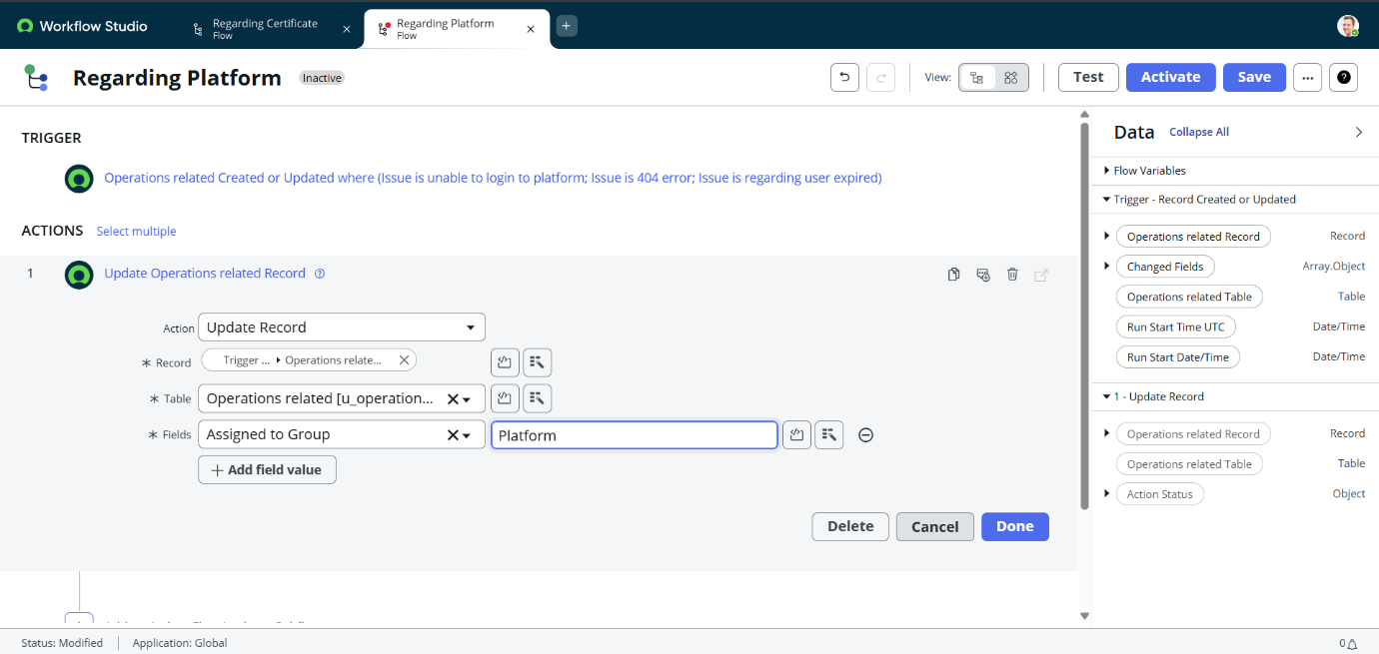
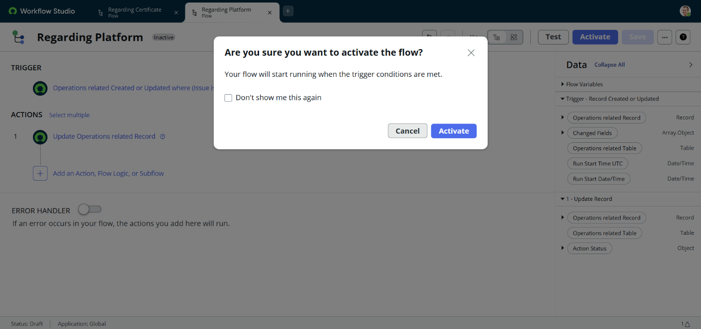
9. CONCLUSION

The project Streamlining Ticket Assignment for Efficient Support Operations successfully demonstrates how automation can improve support ticket management in organizations.
By using the ServiceNow platform, the system automatically assigns tickets to the appropriate support groups based on issue categories. This reduces manual workload, improves operational efficiency, and ensures faster resolution of customer issues.
The automated ticket routing system helps organizations provide better customer support services and enhances overall productivity within the support department.

